
SILENT FAILURE DETECTION
IN DISTRIBUTED SYSTEMS
Using Google Borg Cluster Traces

PROJECT REPORT

Submitted by
Aditya Aryan Jha
Registration Number: 24BDS1134

Abstract

Distributed systems function across numerous machines and handle workloads that vary in CPU, memory, scheduling, and temporal attributes. Some operational issues may initially present themselves as atypical resource behavior rather than as a distinct failure. This study investigates the Google Borg Cluster Trace Dataset to determine if such patterns can be identified for further analysis. The original dataset comprised 405,894 records and 34 raw columns. A reproducible sample of 40,000 records was analyzed. Preprocessing eliminated index artifacts and a duplicate column, parsed nested resource fields, addressed invalid and missing numeric values, and resulted in a cleaned dataset containing 60 columns. Feature engineering generated 116 derived features, with 113 of those retained as predictors suitable for modeling.
The analysis employed supervised classifiers to forecast the explicit 'failed' label of the dataset and utilized unsupervised detectors—specifically Isolation Forest, Local Outlier Factor (LOF), and One-Class SVM to detect atypical observations without relying on that label for training the detectors. A leakage audit revealed event fields that encoded the target perfectly, along with several other high-risk predictors. As a result, a focus was placed on grouped and grouped-temporal validation rather than random-split outcomes. In the grouped split, Random Forest recorded the highest PR-AUC at 0.5275, while SVM (RBF) reached the highest ROC-AUC of 0.8382 among the models assessed. The One-Class SVM flagged group demonstrated the most significant explicit-failure enrichment, approximately 1.52 times. Additionally, a composite degradation score yielded a ROC-AUC of 0.6008 concerning the explicit-failure signal and a top-to-bottom decile lift of 3.0 times.

4. Introduction

4.1 Background

Modern distributed systems rely on a network of interconnected machines, schedulers, and services. Their reliability can be impacted by resource contention, unusual task behaviors, fluctuations in workload, and variations at the machine level. Traditional monitoring systems typically respond to clear error or failure events; however, identifying atypical resource usage patterns may serve as early warning signs, even if these traces do not explicitly categorize them as failures.

4.2 Problem Statement

The project poses the question: Can we utilize resource utilization, machine-level behaviors, and temporal patterns found in Google Borg cluster traces to detect indicators of silent system degradation prior to a noticeable failure occurring?

4.3 Objectives

Examine and validate the data from Google Borg cluster traces.
Clean and transform data related to resources, events, scheduling, and timing.
Develop features related to CPU, memory, tasks, machines, clusters, and time.
Analyze distributions, instances of missing data, interrelationships, and temporal behaviors using R.
Train supervised models targeting the explicit "failed" outcome and evaluate them through leakage-aware data splits.
Implement unsupervised anomaly detection methods and compare identified groups with instances of explicit failures.
Create a composite score for degradation and assess feature significance using model interpretability techniques.

4.4 Scope and Interpretation

The task at hand is focused on predicting explicit failures rather than directly teaching a system to recognize silent failures. The unsupervised component is tasked with detecting abnormal behavior. These findings are potential areas for further inquiry, rather than definitive silent failures. The link to the 'failed' field serves solely as a form of indirect validation.
5. Data Set Description
The project uses the Google Borg Cluster Trace Dataset, which records operational activity from Google's Borg cluster management environment. The records contain information about task events, collections, machines, scheduling, time, resource requests and observed resource usage.
Dataset property | Recorded project value
Full source dataset | 405,894 rows × 34 raw columns
Analysed sample | 40,000 randomly sampled rows
Machines represented in sample | 33,686
Explicit failure target | `failed`
No explicit failure | 30,829 (77.07%)
Explicit failure | 9,171 (22.93%)
After preprocessing | 40,000 rows × 60 columns
Engineered features | 116 total; 113 model-safe

Representative raw attributes include machine_id, collection_id, instance_index, time, event, scheduling_class, priority, assigned_memory, cycles_per_instruction and memory_accesses_per_instruction. The exact columns available to a particular stage depend on parsing and feature construction.
5.1 Target-label limitation

The `failed` column is an explicit failure indicator. The trace does not include an independent label stating that an observation is a silent failure. The project therefore avoids relabelling anomalies as confirmed silent failures.
6. EDA and Visualizations

Exploratory data analysis was conducted using R. The provided R script utilizes readr for handling CSV input/output, dplyr and tidyr for manipulating data, ggplot2 for creating charts, corrplot for visualizing correlations, and scales for formatting scales.

6.1 Data Validation and Preprocessing
The `Unnamed: 0` index artifact and a duplicate event column were removed.
An evaluation for duplicate records revealed that there were no exact duplicate rows in the dataset.
Nested resource dictionaries were parsed into numeric fields, and CPU distribution arrays were expanded into percentile features.
Infinite values and physically invalid negative resource values were replaced with missing values.
Performance counters were imputed using cluster medians, and a missingness indicator was included.
Remaining numeric fields were imputed with medians, intentionally avoiding a global drop-NA operation.
Extreme resource observations were preserved instead of being winsorized.
After the preprocessing run, the number of missing values decreased from 60,711 to zero, and all 40,000 sampled rows were retained. The resulting cleaned dataset comprised 60 columns and had a size of approximately 24 MB.

6.2 Feature Engineering
Feature Group Count of Engineered Features
CPU-: 17
Memory-: 15
Machine-: 12
Task-: 17
Temporal-: 5
Collection Temporal-: 38
Performance Counters -: 7
Cluster-: 5
Total -: 116

After removing target re-encodings, identifiers, and keys, the model-safe feature whitelist included 113 variables. Some examples of these variables are CPU variability and tail metrics, memory pressure, temporal gaps, context at the collection level, and summaries at the machine level.

6.3 Visualizations

The R analysis script generates the following plots, which are stored in `outputs/R_analysis/plots`:

- Overview of the dataset, showing row and column counts.
- Missing value counts for each feature.
- Distribution of instance events.
- Distribution of CPU cycles per instruction.
- Distribution of assigned memory.
- Scatter plot of CPU versus assigned memory, based on a sample of up to 20,000 points.
- Distribution of priorities.
- Activity levels of the top 20 machines.
- Trend of CPU metrics over time, utilizing 50 time windows.
- Correlation heatmap for numerical features.

Additionally, the script generates failure distribution and resource-by-failure plots only if a `failed` column is present. The presentation also includes references to other exploratory data analysis (EDA) figures such as scheduling class distribution, cluster distribution, a vertical scaling box plot, and a correlation heatmap.

6.4 Existing project result screenshots
The following figures are rendered screenshots of the project's previously prepared presentation slides. They are included as project-result evidence, not represented as raw RStudio screenshots.

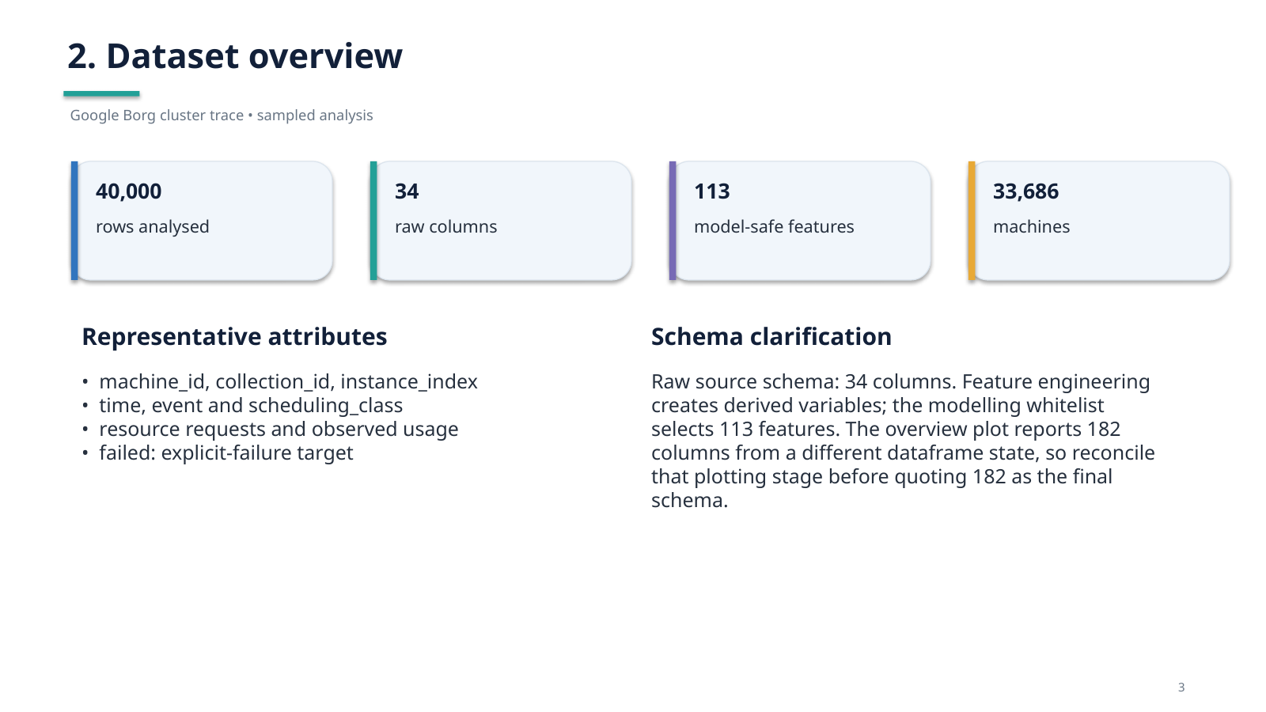
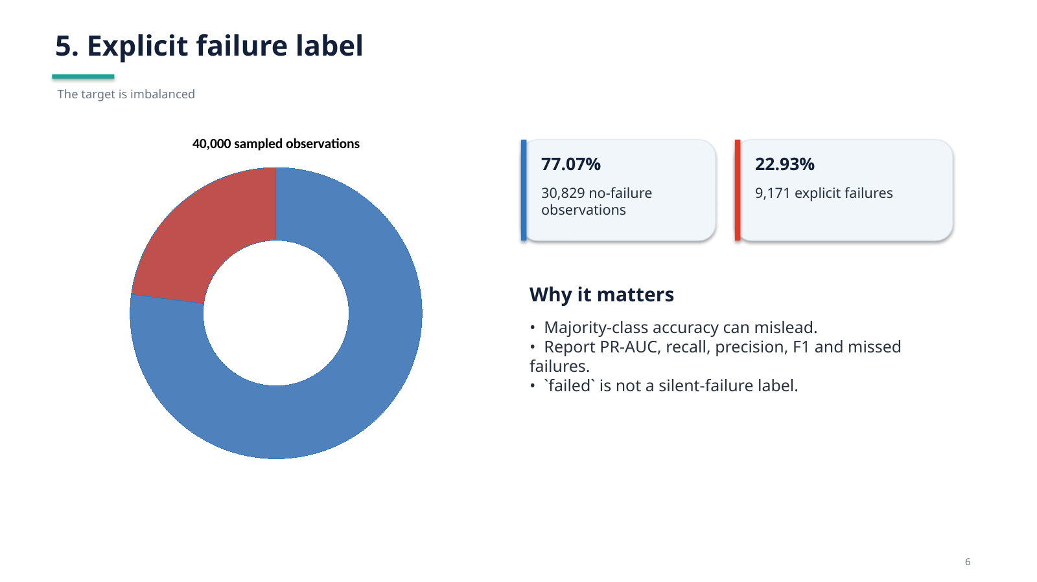
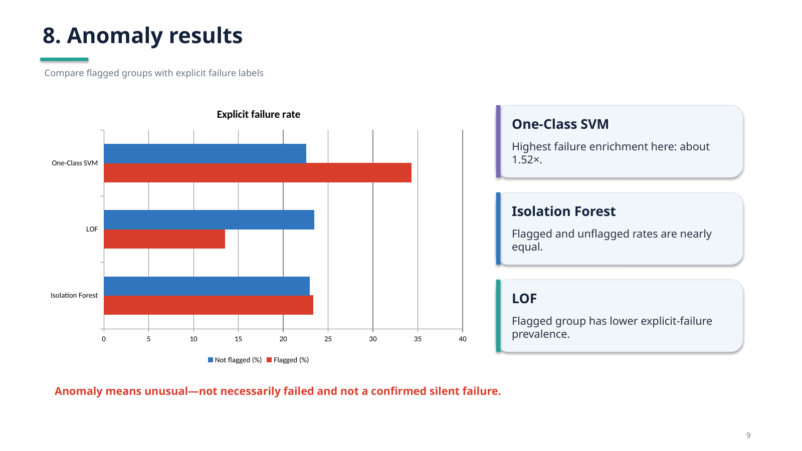
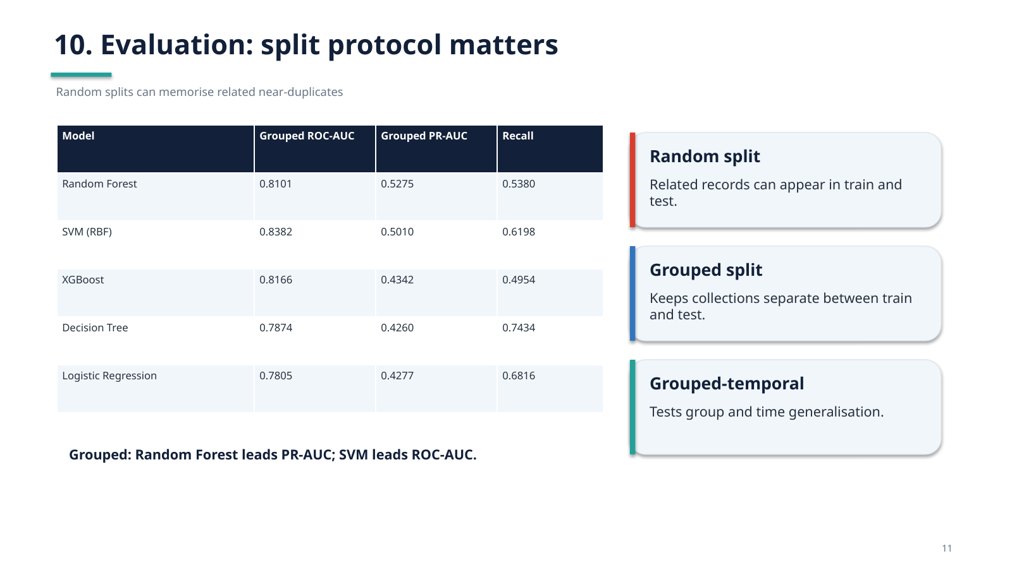
7. Statistical Analysis
7.1 Class distribution
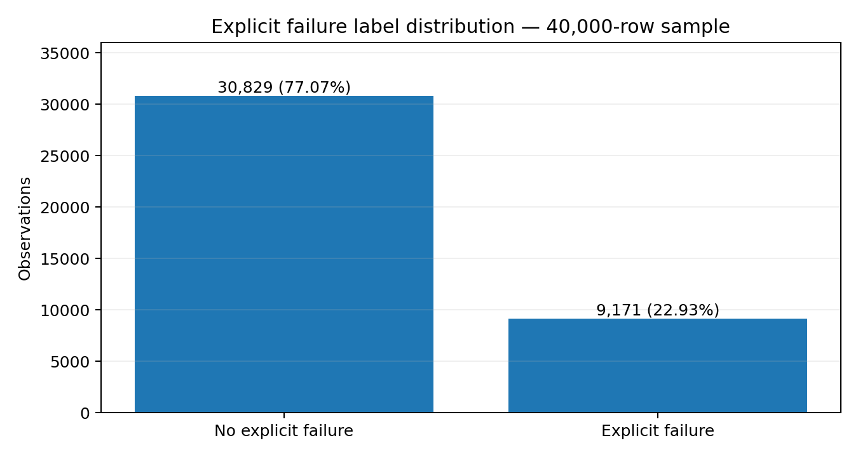

The positive class represents 22.93% of the sample, while 77.07% are labelled as no explicit failure. This imbalance means accuracy alone is insufficient. Precision, recall, F1-score, ROC-AUC and especially PR-AUC are useful complementary measures.

7.2 Leakage audit
Feature | Target purity | Audit decision
instance_events_type | 1.000000 | Perfect target re-encoding
collections_events_type | 1.000000 | Perfect target re-encoding
event | 1.000000 | Perfect target re-encoding
start_time | 0.925025 | Severe leakage risk
end_time | 0.919425 | Severe leakage risk
maximum_usage | 0.916175 | Severe leakage risk
average_usage | 0.913825 | Severe leakage risk
The leakage audit is important because random splits can place related observations in both training and test sets. The resulting scores can look unusually high. The grouped split keeps collection groups separate; grouped-temporal validation additionally tests generalisation across groups and time.
7.3 Degradation score
Six components were combined: CPU stall pressure, memory pressure, resource variability, tail-latency pressure, telemetry incompleteness and provisioning mismatch. Equal-weight, PCA-based and Mahalanobis weighting methods did not agree consistently. The reported score-as-ranker ROC-AUC against the explicit-failure signal was 0.6008, with a top-to-bottom decile lift of 3.0×. This is a weak but non-trivial association and is not a standalone failure predictor.
8. ML Models Used (with Diagram)
The machine-learning pipeline has two very distinct branches. Supervised classifiers learn to predict the explicit `failed` label. Unsupervised detectors identify unusual observations without training on `failed`.
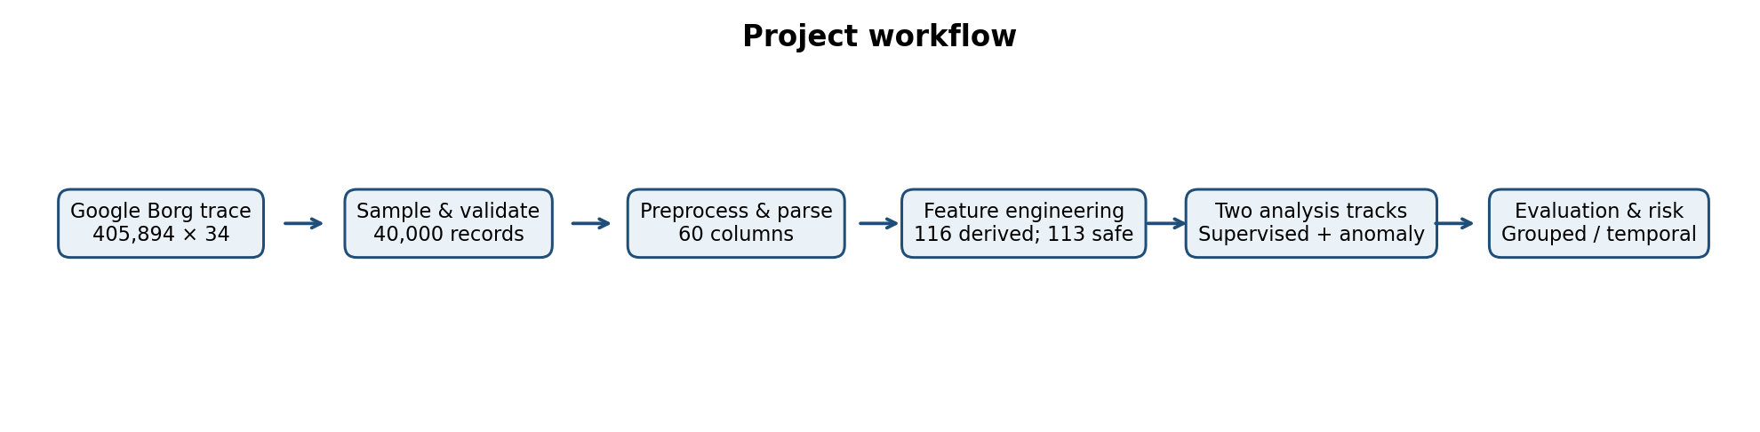
Figure 7. End-to-end project workflow based on the recorded pipeline.
8.1 Supervised classification models
Model | Role in the project
Logistic Regression | Interpretable linear baseline classifier.
Decision Tree | Rule-based nonlinear classifier; can overfit.
Random Forest | Ensemble of decision trees; captures nonlinear interactions.
K-Nearest Neighbors (KNN) | Neighbour-based classifier; sensitive to feature scaling.
Support Vector Machine (RBF) | Nonlinear margin-based classifier.
Gradient Boosting | Sequential tree ensemble.
XGBoost | Regularised gradient-boosted tree implementation.
8.2 Unsupervised anomaly detectors
Detector | Principle
Isolation Forest | Uses random partitioning to isolate unusual observations.
Local Outlier Factor (LOF) | Identifies observations with unusually low local density.
One-Class SVM | Learns a boundary around the majority of the data.
A consensus anomaly flag was also produced when at least two applicable detectors agreed. Consensus increases agreement strictness but does not prove that an observation is a failure.
8.3 Model evaluation architecture
Random split: 32,000 training and 8,000 test observations; related groups can appear on both sides.
Grouped split: 31,627 training and 8,373 test observations; no collection groups overlap.
Grouped-temporal split: 33,581 training and 6,419 test observations; tests group and temporal generalisation.
9. Output Screen Shot (Results)
9.1 Supervised model results — grouped split
Model | Acc. | Prec. | Recall | F1 | ROC-AUC | PR-AUC
Random Forest | 0.8321 | 0.5003 | 0.5380 | 0.5185 | 0.8101 | 0.5275
SVM (RBF) | 0.8130 | 0.4582 | 0.6198 | 0.5269 | 0.8382 | 0.5010
XGBoost | 0.8155 | 0.4550 | 0.4954 | 0.4743 | 0.8166 | 0.4342
Decision Tree | 0.7688 | 0.3991 | 0.7434 | 0.5194 | 0.7874 | 0.4260
Logistic Regression | 0.7558 | 0.3752 | 0.6816 | 0.4840 | 0.7805 | 0.4277
KNN | 0.7930 | 0.4141 | 0.5586 | 0.4756 | 0.7488 | 0.3627
Gradient Boosting | 0.7619 | 0.3367 | 0.4300 | 0.3777 | 0.7455 | 0.2751
On the grouped split, Random Forest recorded the highest PR-AUC (0.5275), while SVM (RBF) recorded the highest ROC-AUC (0.8382). Decision Tree had one of the highest recall (0.7434) in this grouped comparison. These are different operating trade-offs; no single model is best on every metric.

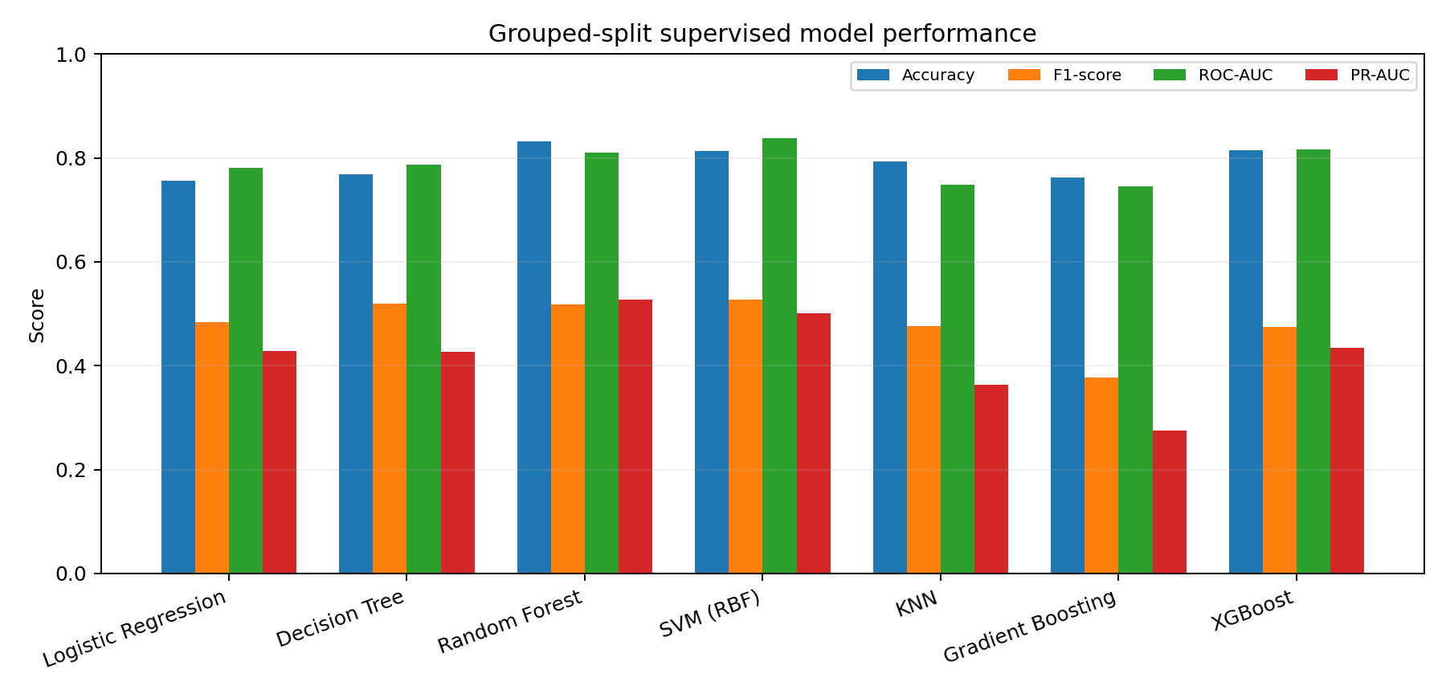
Figure 8. Grouped-split model metrics from the recorded run.
9.2 Grouped-temporal results
Model | Accuracy | F1 | ROC-AUC | PR-AUC
XGBoost | 0.8637 | 0.5709 | 0.8842 | 0.6840
Random Forest | 0.8579 | 0.5033 | 0.7878 | 0.5905
Gradient Boosting* | 0.8230 | 0.3696 | 0.8235 | 0.5396
Decision Tree | 0.6834 | 0.4181 | 0.7654 | 0.5262
SVM (RBF)* | 0.6724 | 0.3547 | 0.6611 | 0.3628
KNN* | 0.7034 | 0.2974 | 0.6560 | 0.2632
Logistic Regression | 0.6355 | 0.3997 | 0.6291 | 0.2709
*For the grouped-temporal run, Gradient Boosting, KNN and SVM were trained on stratified 12,000-row training subsamples because of their computational cost; the run log explicitly records this.
XGBoost achieved the strongest grouped-temporal ROC-AUC (0.8842) and PR-AUC (0.6840), with accuracy 0.8637 and recall 0.4565. This is the strongest reported temporal-generalisation result by ROC-AUC and PR-AUC.

Failure rate by scheduling class
Approximate rates:
- Class 0: 15%
- Class 1: 24%
- Class 2: 24%
- Class 3: 36%
Class 3 has the highest rate in this chart, while class 0 has the lowest.
Interpretation: Scheduling classes have different observed failure rates. Verify the dataset's definitions for the numeric category codes before giving them operational names.

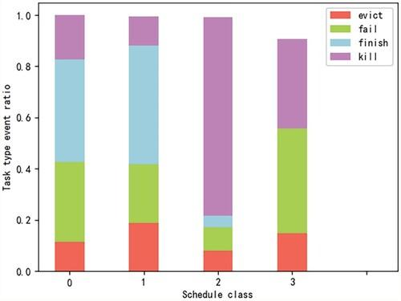

Failure rate by priority tier
Approximate rates in the displayed categories:
- Priority 0: 19%
- Priority 1: 16.5%
- Priority 2: 26.8%
- Priority 3: 34.1%
- Priority 4: 24.7%
Categories 2, 3, and 4 exceed the overall baseline, while categories 0 and 1 fall below it.
Interpretation: Explicit failure rates vary by priority tier. The graph does not establish that priority itself causes failure; other workload characteristics may differ between groups.

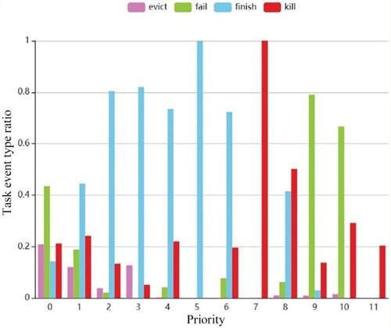

Built-in feature importance
The highest-ranked features include collection_size, time_is_valid, time_since_prev_event, t_hours_from_start, and day_index.
Built-in Random Forest importance usually measures how much a feature reduces impurity across the trees.
Limitation: It can favour variables with many possible split points and can distribute importance unpredictably among correlated features.

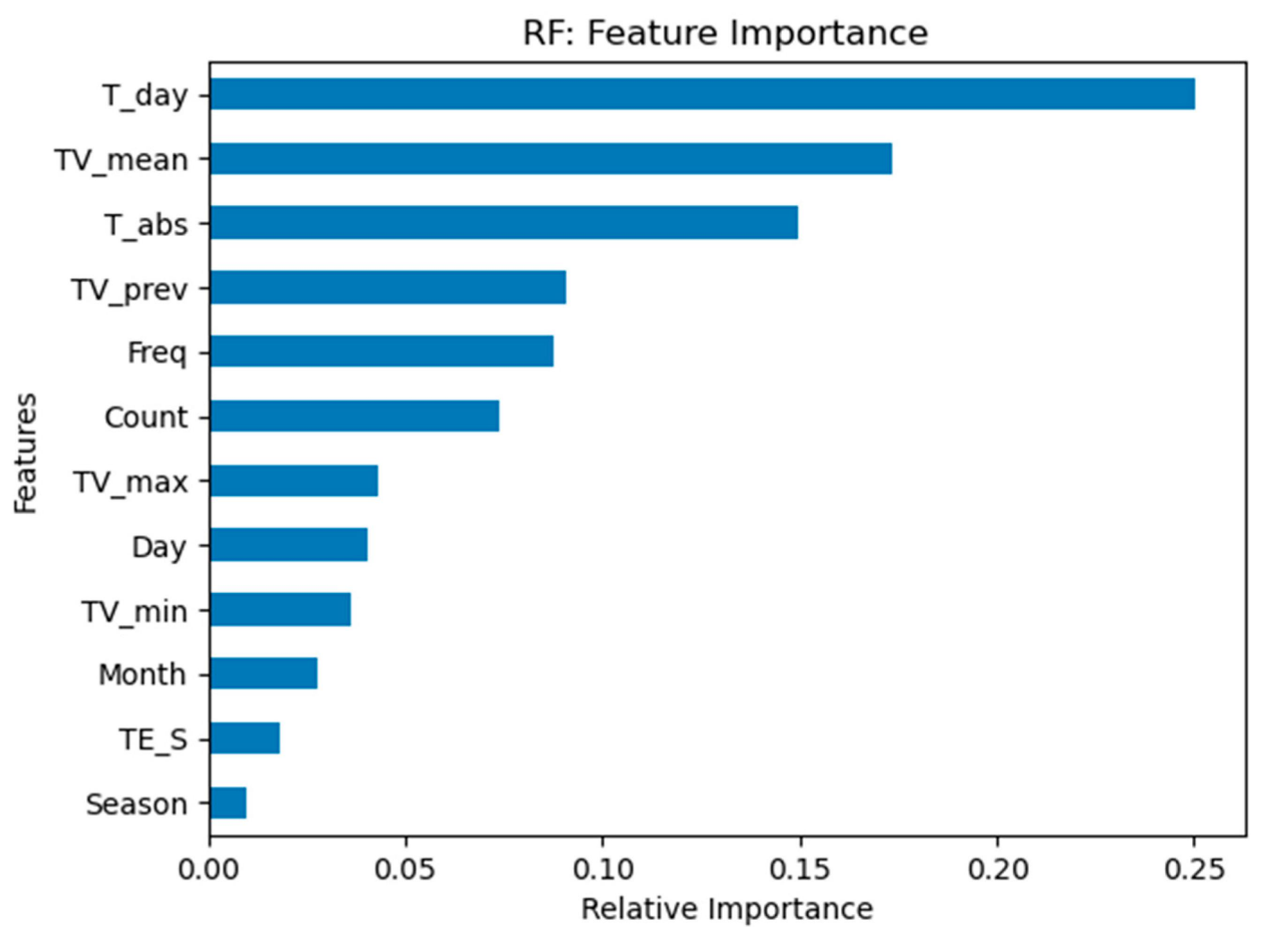
9.3 Random-split results and leakage caution
The random split produced very high results for some ensembles (for example, XGBoost accuracy 0.9910 and PR-AUC 0.9981). These numbers should not be presented as the principal evidence because related records can cross the train/test boundary and leakage risks were identified. Grouped and grouped-temporal results are more conservative and more informative for generalisation.
9.4 Unsupervised anomaly results
Detector | Flagged observations | Failure enrichment
Isolation Forest | 2,000 | 1.0171×
Local Outlier Factor | 2,000 | 0.5763×
One-Class SVM | 1,009 | 1.5198×
Consensus (at least 2 detectors) | 554 | Not reported as enrichment
One-Class SVM had the strongest observed enrichment: its flagged group had approximately 1.52 times the explicit-failure prevalence of the sample baseline. Isolation Forest was close to baseline, while LOF's flagged group had lower explicit-failure prevalence. Anomaly status therefore cannot be treated as synonymous with failure.
9.5 Five-fold grouped cross-validation
Random Forest grouped 5-fold cross-validation reported mean ROC-AUC 0.8211 (standard deviation 0.0455) and mean PR-AUC 0.6089 (standard deviation 0.0309). This provides a measure of fold-to-fold variation under grouped validation.
9.6 Explainability
Top feature | Permutation importance mean
time_is_valid | 0.123672
collection_size | 0.064906
day_index | 0.057905
time_since_prev_event | 0.054354
t_hours_from_start | 0.051460
The project generated native feature importance, held-out permutation importance and SHAP summaries for the Random Forest. The same leading variables appeared across explainability methods. Feature importance describes how the fitted model uses inputs; it does not establish causal relationships.
10. Conclusion
This project established an end-to-end workflow for analysing Google Borg cluster traces, from loading and cleaning to feature engineering, exploratory analysis, explicit-failure classification, anomaly detection, degradation scoring and explainability. The 40,000-record sample was transformed from 34 raw columns to 60 cleaned columns, and 116 engineered features were registered, with 113 selected as model-safe.
The results demonstrate why evaluation design matters. Random-split performance was substantially more optimistic than grouped validation. Under grouped validation, Random Forest achieved the best PR-AUC (0.5275), while SVM (RBF) achieved the best ROC-AUC (0.8382). Under grouped-temporal validation, XGBoost led with ROC-AUC 0.8842 and PR-AUC 0.6840. Unsupervised One-Class SVM showed the strongest enrichment against the explicit-failure label (about 1.52×), while the composite degradation score achieved ROC-AUC 0.6008.
The principal limitation is the absence of an independent silent-failure ground-truth label. The project therefore produces warning candidates and predicts explicit failures; it does not prove that a flagged observation is a silent failure. Future work should validate alerts against confirmed incident timelines, test additional trace windows, monitor data drift, calibrate thresholds to operational alert costs and continue strict grouped-temporal evaluation.

11. R Code

The following appendix reproduces the uploaded `complete_R_analysis.R` script supplied for this report. It performs R-side loading, validation, feature construction, EDA, visualisation and PDF report generation. The supervised and unsupervised model results reported in Sections 8–9 come from the recorded Python pipeline logs and project presentation; they are not produced by this R script.
# ==============================================================
# COMPLETE R ANALYSIS PIPELINE
# Project: Silent Failure Detection in Distributed Systems
# Dataset: Google Borg Cluster Trace
#
# Performs:
# 1. Data loading
# 2. Data preprocessing
# 3. Data validation
# 4. Feature engineering
# 5. Exploratory Data Analysis
# 6. Visualization
# 7. PDF report generation
# ==============================================================
# ==============================================================
# 0. INSTALL / LOAD REQUIRED PACKAGES
# ==============================================================
required_packages <- c(
"readr",
"dplyr",
"ggplot2",
"tidyr",
"corrplot",
"scales"
)
for (pkg in required_packages) {
if (!require(pkg, character.only = TRUE)) {
install.packages(pkg)
library(pkg, character.only = TRUE)
}
}
# ==============================================================
# 1. PROJECT PATHS
# ==============================================================
cat("\n==============================================\n")
cat(" SILENT FAILURE DETECTION - R ANALYSIS\n")
cat("==============================================\n\n")
# Change this ONLY if your CSV is somewhere else
dataset_path <- "data/raw/borg_traces_data.csv"
# Output directories
output_dir <- "outputs/R_analysis"
plot_dir <- file.path(output_dir, "plots")
if (!dir.exists(output_dir)) {
dir.create(output_dir, recursive = TRUE)
}
if (!dir.exists(plot_dir)) {
dir.create(plot_dir, recursive = TRUE)
}
# ==============================================================
# 2. LOAD DATASET
# ==============================================================
cat("STEP 1: Loading Google Borg dataset...\n")
if (!file.exists(dataset_path)) {
stop(
paste(
"\nDataset not found at:",
dataset_path,
"\n\nPut borg_traces_data.csv inside:",
"data/raw/"
)
)
}
borg_data <- read_csv(
dataset_path,
show_col_types = FALSE
)
cat("Dataset loaded successfully!\n\n")
cat("Rows :", nrow(borg_data), "\n")
cat("Columns :", ncol(borg_data), "\n\n")
# ==============================================================
# 3. CLEAN COLUMN NAMES
# ==============================================================
cat("STEP 2: Cleaning column names...\n")
# Rename unnamed first column
if ("...1" %in% colnames(borg_data)) {
borg_data <- borg_data %>%
rename(record_id = `...1`)
}
# Remove accidental duplicate columns
borg_data <- borg_data[, !duplicated(colnames(borg_data))]
cat("Column names cleaned.\n\n")
# ==============================================================
# 4. BASIC DATA VALIDATION
# ==============================================================
cat("STEP 3: Validating dataset...\n")
initial_rows <- nrow(borg_data)
# Count duplicate rows
duplicate_count <- sum(duplicated(borg_data))
cat("Duplicate rows:", duplicate_count, "\n")
# Remove duplicates
borg_data <- borg_data %>%
distinct()
after_duplicate_rows <- nrow(borg_data)
cat(
"Rows removed:",
initial_rows - after_duplicate_rows,
"\n\n"
)
# ==============================================================
# 5. HANDLE MISSING VALUES
# ==============================================================
cat("STEP 4: Checking missing values...\n")
missing_summary <- data.frame(
column = names(borg_data),
missing_count = sapply(
borg_data,
function(x) sum(is.na(x))
)
)
missing_summary <- missing_summary %>%
arrange(desc(missing_count))
print(missing_summary)
write_csv(
missing_summary,
file.path(output_dir, "missing_values.csv")
)
# ==============================================================
# 6. CONVERT NUMERIC VARIABLES
# ==============================================================
cat("\nSTEP 5: Converting numeric variables...\n")
numeric_columns <- c(
"time",
"instance_events_type",
"collection_id",
"scheduling_class",
"collection_type",
"priority",
"alloc_collection_id",
"instance_index",
"machine_id",
"vertical_scaling",
"scheduler",
"start_time",
"end_time",
"assigned_memory",
"page_cache_memory",
"cycles_per_instruction",
"memory_accesses_per_instruction",
"sample_rate"
)
# Convert only columns that actually exist
numeric_columns <- intersect(
numeric_columns,
names(borg_data)
)
borg_data[numeric_columns] <-
lapply(
borg_data[numeric_columns],
function(x) suppressWarnings(as.numeric(x))
)
cat(
"Converted",
length(numeric_columns),
"numeric variables.\n\n"
)
# ==============================================================
# 7. HANDLE INFINITE VALUES
# ==============================================================
cat("STEP 6: Checking infinite values...\n")
for (i in seq_along(borg_data)) {
if (is.numeric(borg_data[[i]])) {
borg_data[[i]][
is.infinite(borg_data[[i]])
] <- NA
}
}
cat("Infinite values handled.\n\n")
# ==============================================================
# 8. FEATURE ENGINEERING
# ==============================================================
cat("STEP 7: Creating analytical features...\n")
# --------------------------------------------------------------
# Task duration
# --------------------------------------------------------------
if (
all(c("start_time", "end_time") %in% names(borg_data))
) {
borg_data <- borg_data %>%
mutate(
task_duration =
ifelse(
!is.na(start_time) &
!is.na(end_time) &
end_time >= start_time,
end_time - start_time,
NA
)
)
}
# --------------------------------------------------------------
# CPU efficiency
# --------------------------------------------------------------
if (
"cycles_per_instruction" %in% names(borg_data)
) {
borg_data <- borg_data %>%
mutate(
cpu_efficiency =
ifelse(
cycles_per_instruction > 0,
1 / cycles_per_instruction,
NA
)
)
}
# --------------------------------------------------------------
# Memory pressure
# --------------------------------------------------------------
if (
all(
c(
"assigned_memory",
"page_cache_memory"
) %in% names(borg_data)
)
) {
borg_data <- borg_data %>%
mutate(
memory_pressure =
page_cache_memory /
pmax(assigned_memory, 1)
)
}
# --------------------------------------------------------------
# CPU / memory inefficiency indicator
# --------------------------------------------------------------
if (
all(
c(
"cycles_per_instruction",
"memory_accesses_per_instruction"
) %in% names(borg_data)
)
) {
borg_data <- borg_data %>%
mutate(
resource_inefficiency =
cycles_per_instruction *
memory_accesses_per_instruction
)
}
# ==============================================================
# 9. CREATE EVENT LABEL
# ==============================================================
if ("instance_events_type" %in% names(borg_data)) {
borg_data <- borg_data %>%
mutate(
event_label =
factor(instance_events_type)
)
}
# ==============================================================
# 10. CREATE FAILURE LABEL IF ALREADY AVAILABLE
# ==============================================================
# IMPORTANT:
# We do NOT invent failure labels.
# If the dataset/preprocessing already contains "failed",
# we use it.
if ("failed" %in% names(borg_data)) {
borg_data <- borg_data %>%
mutate(
failed = as.factor(failed)
)
}
# ==============================================================
# 11. REMOVE EXTREME INVALID VALUES
# ==============================================================
cat("STEP 8: Removing invalid observations...\n")
# Assigned memory cannot be negative
if ("assigned_memory" %in% names(borg_data)) {
borg_data$assigned_memory[
borg_data$assigned_memory < 0
] <- NA
}
# Priority cannot be negative
if ("priority" %in% names(borg_data)) {
borg_data$priority[
borg_data$priority < 0
] <- NA
}
# ==============================================================
# 12. SAVE CLEAN DATASET
# ==============================================================
cleaned_path <- file.path(
output_dir,
"cleaned_borg_data.csv"
)
write_csv(
borg_data,
cleaned_path
)
cat(
"Clean dataset saved to:",
cleaned_path,
"\n\n"
)
# ==============================================================
# 13. PREPROCESSING REPORT
# ==============================================================
report_file <- file.path(
output_dir,
"preprocessing_report.txt"
)
sink(report_file)
cat("=============================================\n")
cat(" PREPROCESSING REPORT\n")
cat(" Google Borg Cluster Dataset\n")
cat("=============================================\n\n")
cat("Original rows:", initial_rows, "\n")
cat(
"Rows after duplicate removal:",
nrow(borg_data),
"\n"
)
cat(
"Original columns:",
ncol(borg_data),
"\n\n"
)
cat("Duplicate rows removed:", duplicate_count, "\n\n")
cat("Missing Value Summary\n")
cat("---------------------------------------------\n")
print(missing_summary)
cat("\n\nFinal Columns\n")
cat("---------------------------------------------\n")
print(names(borg_data))
cat("\n\nFinal Dataset Dimensions\n")
cat("---------------------------------------------\n")
cat(
"Rows:",
nrow(borg_data),
"\n"
)
cat(
"Columns:",
ncol(borg_data),
"\n"
)
sink()
# ==============================================================
# 14. DATASET OVERVIEW GRAPH
# ==============================================================
cat("STEP 9: Creating visualizations...\n")
p1 <- ggplot(
data.frame(
metric = c(
"Rows",
"Columns"
),
value = c(
nrow(borg_data),
ncol(borg_data)
)
),
aes(
x = metric,
y = value
)
) +
geom_col(
fill = "steelblue"
) +
labs(
title =
"Google Borg Dataset Overview",
x = NULL,
y = "Count"
) +
theme_minimal()
ggsave(
file.path(
plot_dir,
"01_dataset_overview.png"
),
p1,
width = 8,
height = 5
)
# ==============================================================
# 15. MISSING VALUE GRAPH
# ==============================================================
missing_plot_data <- missing_summary %>%
filter(
missing_count > 0
) %>%
arrange(
desc(missing_count)
)
if (nrow(missing_plot_data) > 0) {
p2 <- ggplot(
missing_plot_data,
aes(
x = reorder(
column,
missing_count
),
y = missing_count
)
) +
geom_col(
fill = "firebrick"
) +
coord_flip() +
labs(
title =
"Missing Values by Feature",
x = "Feature",
y = "Missing Values"
) +
theme_minimal()
ggsave(
file.path(
plot_dir,
"02_missing_values.png"
),
p2,
width = 9,
height = 6
)
}
# ==============================================================
# 16. EVENT DISTRIBUTION
# ==============================================================
if ("instance_events_type" %in% names(borg_data)) {
p3 <- ggplot(
borg_data,
aes(
x = factor(instance_events_type)
)
) +
geom_bar(
fill = "darkorange"
) +
labs(
title =
"Instance Event Distribution",
x =
"Instance Event Type",
y =
"Number of Records"
) +
theme_minimal()
ggsave(
file.path(
plot_dir,
"03_event_distribution.png"
),
p3,
width = 9,
height = 6
)
}
# ==============================================================
# 17. FAILURE DISTRIBUTION
# ==============================================================
if ("failed" %in% names(borg_data)) {
p4 <- ggplot(
borg_data,
aes(
x = failed
)
) +
geom_bar(
fill = "tomato"
) +
labs(
title =
"Failure Distribution",
x =
"Failure Status",
y =
"Number of Records"
) +
theme_minimal()
ggsave(
file.path(
plot_dir,
"04_failure_distribution.png"
),
p4,
width = 8,
height = 5
)
}
# ==============================================================
# 18. CPU DISTRIBUTION
# ==============================================================
if ("cycles_per_instruction" %in% names(borg_data)) {
p5 <- ggplot(
borg_data,
aes(
x = cycles_per_instruction
)
) +
geom_histogram(
bins = 50,
fill = "dodgerblue",
color = "white"
) +
labs(
title =
"CPU Efficiency Indicator Distribution",
x =
"Cycles per Instruction",
y =
"Frequency"
) +
theme_minimal()
ggsave(
file.path(
plot_dir,
"05_cpu_distribution.png"
),
p5,
width = 9,
height = 6
)
}
# ==============================================================
# 19. MEMORY DISTRIBUTION
# ==============================================================
if ("assigned_memory" %in% names(borg_data)) {
p6 <- ggplot(
borg_data,
aes(
x = assigned_memory
)
) +
geom_histogram(
bins = 50,
fill = "mediumpurple",
color = "white"
) +
labs(
title =
"Assigned Memory Distribution",
x =
"Assigned Memory",
y =
"Frequency"
) +
theme_minimal()
ggsave(
file.path(
plot_dir,
"06_memory_distribution.png"
),
p6,
width = 9,
height = 6
)
}
# ==============================================================
# 20. CPU VS MEMORY
# ==============================================================
if (
all(
c(
"cycles_per_instruction",
"assigned_memory"
) %in% names(borg_data)
)
) {
sample_data <- borg_data %>%
select(
cycles_per_instruction,
assigned_memory
) %>%
filter(
is.finite(cycles_per_instruction),
is.finite(assigned_memory)
) %>%
slice_sample(
n = min(20000, n())
)
p7 <- ggplot(
sample_data,
aes(
x =
cycles_per_instruction,
y =
assigned_memory
)
) +
geom_point(
alpha = 0.25
) +
labs(
title =
"CPU Efficiency vs Assigned Memory",
x =
"Cycles per Instruction",
y =
"Assigned Memory"
) +
theme_minimal()
ggsave(
file.path(
plot_dir,
"07_cpu_vs_memory.png"
),
p7,
width = 9,
height = 6
)
}
# ==============================================================
# 21. RESOURCE METRICS BY FAILURE
# ==============================================================
if (
all(
c(
"failed",
"assigned_memory"
) %in% names(borg_data)
)
) {
resource_data <- borg_data %>%
select(
failed,
assigned_memory
) %>%
filter(
!is.na(failed),
!is.na(assigned_memory)
)
p8 <- ggplot(
resource_data,
aes(
x = failed,
y = assigned_memory
)
) +
geom_boxplot(
alpha = 0.7
) +
labs(
title =
"Assigned Memory by Failure Status",
x =
"Failure Status",
y =
"Assigned Memory"
) +
theme_minimal()
ggsave(
file.path(
plot_dir,
"08_resource_by_failure.png"
),
p8,
width = 9,
height = 6
)
}
# ==============================================================
# 22. PRIORITY DISTRIBUTION
# ==============================================================
if ("priority" %in% names(borg_data)) {
p9 <- ggplot(
borg_data,
aes(
x = priority
)
) +
geom_histogram(
bins = 30,
fill = "seagreen",
color = "white"
) +
labs(
title =
"Priority Distribution",
x =
"Priority",
y =
"Frequency"
) +
theme_minimal()
ggsave(
file.path(
plot_dir,
"09_priority_distribution.png"
),
p9,
width = 9,
height = 6
)
}
# ==============================================================
# 23. MACHINE ACTIVITY
# ==============================================================
if ("machine_id" %in% names(borg_data)) {
machine_data <- borg_data %>%
count(
machine_id,
name = "records"
) %>%
arrange(
desc(records)
) %>%
slice_head(
n = 20
)
p10 <- ggplot(
machine_data,
aes(
x = reorder(
factor(machine_id),
records
),
y = records
)
) +
geom_col(
fill = "steelblue"
) +
coord_flip() +
labs(
title =
"Top 20 Machines by Recorded Activity",
x =
"Machine ID",
y =
"Number of Records"
) +
theme_minimal()
ggsave(
file.path(
plot_dir,
"10_machine_activity.png"
),
p10,
width = 9,
height = 7
)
}
# ==============================================================
# 24. TEMPORAL TREND
# ==============================================================
if (
all(
c(
"time",
"cycles_per_instruction"
) %in% names(borg_data)
)
) {
temporal_data <- borg_data %>%
select(
time,
cycles_per_instruction
) %>%
filter(
!is.na(time),
!is.na(cycles_per_instruction)
) %>%
arrange(time)
# Divide observations into time windows
temporal_data <- temporal_data %>%
mutate(
time_window =
ntile(
time,
50
)
) %>%
group_by(
time_window
) %>%
summarise(
time =
median(
time,
na.rm = TRUE
),
cpu_efficiency =
median(
cycles_per_instruction,
na.rm = TRUE
),
.groups = "drop"
)
p11 <- ggplot(
temporal_data,
aes(
x = time,
y = cpu_efficiency
)
) +
geom_line(
linewidth = 1
) +
labs(
title =
"CPU Efficiency Trend Over Time",
x =
"Time",
y =
"Median Cycles per Instruction"
) +
theme_minimal()
ggsave(
file.path(
plot_dir,
"11_temporal_trend.png"
),
p11,
width = 10,
height = 6
)
}
# ==============================================================
# 25. CORRELATION HEATMAP
# ==============================================================
cat("Generating correlation heatmap...\n")
numeric_data <- borg_data %>%
select(
where(is.numeric)
)
# Remove columns with no variation
numeric_data <- numeric_data[
sapply(
numeric_data,
function(x) {
variance <-
var(
x,
na.rm = TRUE
)
is.finite(variance) &&
variance > 0
}
)
]
if (ncol(numeric_data) >= 2) {
correlation_matrix <- cor(
numeric_data,
use = "pairwise.complete.obs"
)
png(
filename =
file.path(
plot_dir,
"12_correlation_heatmap.png"
),
width = 1400,
height = 1100
)
corrplot(
correlation_matrix,
method = "color",
type = "upper",
order = "hclust",
tl.col = "black",
tl.cex = 0.65,
number.cex = 0.5,
addCoef.col = "black",
number.digits = 2
)
dev.off()
}
# ==============================================================
# 26. GENERATE PDF REPORT
# ==============================================================
cat("\nGenerating PDF report...\n")
pdf(
file.path(
output_dir,
"R_EDA_Report.pdf"
),
width = 10,
height = 7
)
print(p1)
if (exists("p2")) {
print(p2)
}
if (exists("p3")) {
print(p3)
}
if (exists("p4")) {
print(p4)
}
if (exists("p5")) {
print(p5)
}
if (exists("p6")) {
print(p6)
}
if (exists("p7")) {
print(p7)
}
if (exists("p8")) {
print(p8)
}
if (exists("p9")) {
print(p9)
}
if (exists("p10")) {
print(p10)
}
if (exists("p11")) {
print(p11)
}
# Correlation heatmap
if (exists("correlation_matrix")) {
corrplot(
correlation_matrix,
method = "color",
type = "upper",
order = "hclust",
tl.col = "black",
tl.cex = 0.65,
number.cex = 0.5,
addCoef.col = "black"
)
}
dev.off()
# ==============================================================
# 27. FINAL SUMMARY
# ==============================================================
cat("\n")
cat("====================================================\n")
cat(" R ANALYSIS COMPLETED SUCCESSFULLY\n")
cat("====================================================\n\n")
cat("Dataset:\n")
cat(
"Rows :",
nrow(borg_data),
"\n"
)
cat(
"Columns :",
ncol(borg_data),
"\n\n"
)
cat("Generated:\n")
cat(
"✓ Cleaned dataset\n"
)
cat(
"✓ Preprocessing report\n"
)
cat(
"✓ Missing-value analysis\n"
)
cat(
"✓ Event distribution\n"
)
cat(
"✓ Failure distribution\n"
)
cat(
"✓ CPU distribution\n"
)
cat(
"✓ Memory distribution\n"
)
cat(
"✓ CPU vs memory analysis\n"
)
cat(
"✓ Resource vs failure analysis\n"
)
cat(
"✓ Priority distribution\n"
)
cat(
"✓ Machine activity analysis\n"
)
cat(
"✓ Temporal analysis\n"
)
cat(
"✓ Correlation heatmap\n"
)
cat(
"✓ PDF EDA report\n\n"
)
cat(
"Output directory:",
output_dir,
"\n"
)
cat("\n====================================================\n")
cat(" DONE!\n")
cat("====================================================\n")
12. GitHub Repository
The project source repository is available at the following URL:
https://github.com/aajbelga/Silent-Failure-Detection-in-Distributed-Systems

